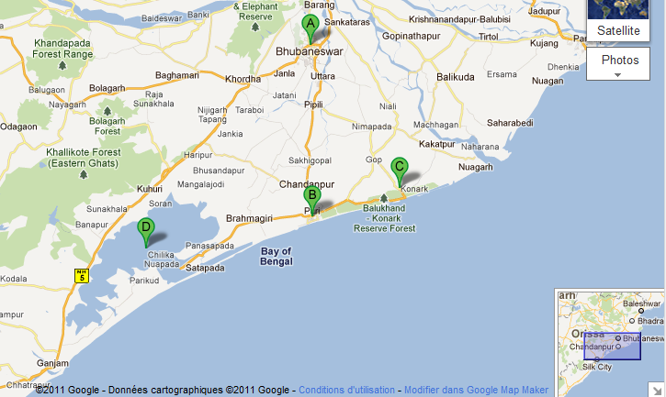

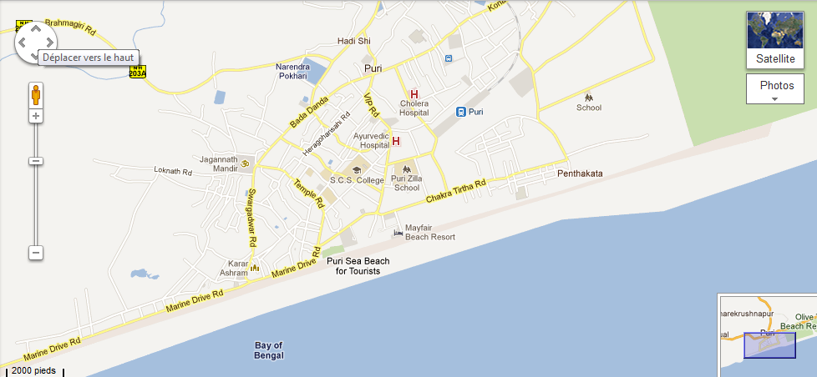

Places To See in Orissa - A lot of architectural wonders and heritage sites at Orissa offer breathtaking views and a wholesome experience to the tourists visiting the state. The beaches in Orissa with some or the other unique feature of their own are the best loved beaches being yet unspoiled. The Puri Beach Festival therefore attracts lots of tourists from all over the world.
Then there is the Sun temple at Konark that stands as mute evidence to exceptional architectural skills of Oriya artists. The Udaigiri and Khandgiri caves are also a potential tourist attraction in Orissa. With exceptional stone carvings, these caves are the best archaeological site at Orissa.

Puri city

Puri's vibrant and narrowly packed streets with brightly painted houses, pastiches of colonial buildings, has a charm of its own. The Jagannath Temple which soars out of these streets dominates the skyline. The Chakratirtha (CT) Road to the East, the waterfront of Marine Drive Road to the West, and the score of hotels, resorts in the middle and the crammed Bada Danda street with lodges and shops selling religious souvenirs and the colourful pattachitra paintings are the hubs of action. The long stretch of coast, much cleaner towards the eastern end, remains crowded with sun bathers and swimmers in the season with local fishermen serving as life guards. Barring the pilgrims, congregating in hundred thousands during the annual Rath Yatra, Puri's traveller scene is dominated by Bengalis from Kolkata and some young western and Japanese visitors exploring the laidback charm of the town mostly on foot or bicycles.
Puri City Guide - According to tradition, originally this dense forested area was inhabited by the Sabaras, a tribal group who predated the Dravidians and the Aryans. It is believed that the Sabaras, originally worshipped the Lord Jagannath as Nilamadhab, and made images of red tree trunks. This deity was later adopted by Brahmins. Some believed it to be the sacred site of Dantaputra, which once held the holy Buddhist Tooth relic. Until the time of its association with the Hindu reformer, Shankaracharya, Puri was an obscure outpost along the coastal trade route linking the South with eastern part of India. The Shankaracharya brought it to the religious map of India as a centre of teaching and learning a more ascetic form of Hinduism and established one of its four mathas here in the 8th century. The beginning of the 12th century witnessed the rise in influence of the Ganga dynasty with which the centre's religious importance got further consolidated. A great temple was founded by Anantavarman Chodaganga in 1135, dedicated to Purushottama (or Vishnu) and the name got changed to Jagannath (Lord of the Universe) in the 15th century during the reign of Gajapatis. The Vaishnava saint Chaitanya Mahaprabhu from Bengal, spent many years at Puri in the 15th century. The temple now dedicated to the worship of Krishna, an incarnation of Vishnu, is one of the four dhams in India.

The spiritual city attracts devotees along with tourists from around the world for witnessing attractions like Temple of Child Krishna at Indradyumna Tank, Atharnala Bridge and Sudarshan Crafts Museum. The city also has the famous Sun Temple of Konark. Among well-known attractions in and around, Puri features Chilka Lake, a large inland salt-water lake, Puri Beach, Gundicha Ghar and the Childlike Wildlife Sanctuary. Over the years, the coastal city has emerged as an industrial centre with major industries like rice milling, handicrafts and fish curing.

Jagannath Temple (Puri)

Belonging to the 11th century and enjoying the honor of being one of the 'char dhams', the pilgrimage that every Hindu intend to visit; Jagannath Temple is the honor of Puri and Orissa. The holy sight of Lord Jagannath, accompanied by Subhadra and Balabhadra raises loads of joy among the devotees. The two gods and the goddess of the temple are ornamented in accordance with the occasion and seasonal change. The structural design of the temple can be found to be in pyramid shape.

You would be excited to know that the Jagannath Temple of Puri has a latent legend associated with it. It is believed that in the Krita Yuga, the actual image of the lord had the power of granting 'moksha' to anyone who witnessed it. Yamaraja didn't find this justice. So, he decided to keep the image in some distant and unknown corner of the earth. However, as Dvapar Yuga arrived, the idol that is worshipped today in Jagannath Puri was constructed by Lord Vishnu with the help of wooden logs. And it doesn't make difference in the Lord’s power in spite of having the hands lacking.

Jagannath Temple in Orissa consists of four entrance gates. They are named as Singhadwara, Ashwadwara, Hathidwara and Vyaghradwara and these names refer to lion, horse, elephant and tiger. Each day, the Lord at the Jagannath Temple is offered 'bhoga' six times and it is dispensed among the worshippers close to Ratnavedi.

Now, you must be aspiring to know more about the temple and Jagannath Puri. So, don't wait more to visiting this place. Immediately book a tour package for Orissa and explore various other attractions of Orissa.

Architecture

The architecture of the temple follows the pattern of many Orissan temples of the classical period. The main shikhara, or tower, rises above the inner sanctum where the deities reside. Subsidiary shikharas rise above ante-halls. The temple complex is surrounded by a wall, on each side of which is a gopura or gate, over which rises a pyramid-shaped roof. Being the largest temple in the state, it has a complex covering several square blocks with dozens of structures including a mammoth kitchen.
The main temple structure of this architectural and cultural wonder is 65m (214 feet) high and is built on elevated ground, making it look more imposing. Comprising an area of 10.7 acres, the temple complex is enclosed by two rectangular walls. The outer enclosure is called Meghanada Prachira, 200m (665 ft) by 192m (640 ft). The inner wall is called Kurmabedha, 126m (420 ft) by 95m (315 ft). There are thirty-six traditional communities (Chatisha Niyaga) who render a specific hereditary service to the deities. The temple has as many as 6,000 priests.
There is a wheel on top of the Jagannath Temple made of an alloy of eight metals (asta-dhatu). It is called the Nila Chakra (Blue Wheel), and is 3.5m (11 ft 8 in) high with a circumference of about 11m (36 ft). Every day, a different flag is tied to a mast attached to the Nila Chakra. Every Ekadasi, a lamp is lit on top of the temple near the wheel. There are four gates: the eastern Singhadwara (Lion Gate), the southern Ashwadwara (Horse Gate), the western Vyaghradwara (Tiger Gate), and the northern Hastidwara (Elephant Gate). There is a carving of each form by the entrance of each gate. The Lion Gate, which is the main gate, is located on Grand Road. Thirty different smaller temples surround the main temple. The Narasimha Temple, adjacent to the western side of the Mukti-mandapa, is said to have been constructed before this temple even.

Legend

According to the legend, Indrayumna, the king of Malava in Sata Yuga, was a great devotee of Vishnu. Once the king dreamt of Nilamadhava Vishnu and was curious to know where that particular form of the Lord was worshipped. Therefore, he sent his emissaries in four directions to find this.
Brahmin Vidyapati was sent to the east. He came to Utkala and entered Savara village where he took shelter in the house of the Savara King Visvavasu. Lalita, king's daughter, fell in love with Vidyapati and the latter got married to her to extract information about Nilamadhava.
Visvavasu used to go to the forest every morning to worship Nilamadhava installed in Niakandara (Blue cave). Vidyapati thus coaxed his wife to request her father to allow him to see Nilamadhava. Visvavasu agreed on the condition that Vidyapati will be taken to the shrine and brought back from there with a blindfold.
On hearing this, Vidyapati went to his wife and asked her to make such an arrangement that he may subsequently know the path. Lalita gave him some sesame seeds to be scattered on the side of the road he followed so that he might know the path when sesame plants grew up during the rains.
Accordingly, Vidyapati was taken to Nilakandara where he saw Nilamadhava. Later, when Vasu Savara offered food to the deity, he did not take it as usual to the king's dismay. At this, a divine voice was heard. It said, "we would no longer continue to be worshipped by you. Oh! Vasu, we will change the present Nilamadhava form and assume Daru form. We shall be worshipped in the temple by Raja Indradyumna".
The king came back from the blue cave with a very heavy heart losing his deity. Vidyapati too bade farewell to his wife and father-in-law and started for Malava. Having heard the story, King Indradyumna started with his retinue for Utkal to see Nilamadhava. On reaching Nilakandara, he found it vacant. But a voice from the air told him to construct a temple on Nilasaila (Blue Mountain).
Hearing this, the king ordered the construction to begin. On completion of the temple, the king went to Brahmaloka to invite Brahma to consecrate the temple. But, Brahma being in meditation, he had to wait for nine Yugas. The temple thus got buried in sand in his absence.
In the mean time, a new dynasty came to rule at Utkala. Galamadhva, a king of that dynasty, detected the buried temple. He was considering installing images in the temple when Indradyumna with Lord Brahma appeared before him. Both the kings had a tussle over the ownership of the temple. However, Lord Brahma decided in favor of Indradyumna and asked him to install deities in the temple.
Now, the king was at a loss as to where to find the deities from. Therefore, god told him in his dream that he would be floating in the sea in the form of a log of wood. Then Sage Narada assured Indradyumna that Vishnu would appear to him in the temple form of three wooden images.
When a big tree, radiant with light was seen floating in the sea, Narada told the king to make three idols out of it and place them in a pavilion. Indradyumna got Visvakarma, the architect of Gods, to build a magnificent temple to house the idols and Vishnu himself appeared in the guise of a carpenter to make the idols on condition that he was to be left undisturbed until he finished the work.
But just after two weeks, the Queen became very anxious. She took the carpenter to be dead as no sound came from the temple. Therefore, she requested the king to open the door. Thus, they went to see Vishnu at work at which the latter abandoned his work leaving the idols unfinished. But a divine voice told Indradyumana to install them in the temple.
The three idols represent the god Jagannath, his elder brother, Balabhadra and their sister, Subhadra. The wooden idols being worshipped are renewed during special occasions. This wooden idol prepared from a log of wood floating on the ocean finds a mention in the Rig Veda, where it is referred to as Purushottama.

Sun Temple Konark

http://www.konark.org/konark-sun-temple.htmlOne of the most stunning monuments of religious significance, a true masterpiece of architecture proudly stands in the form of Sun Temple at Konark. A culmination of Oriya architecture, the temple is a wonderful place as the language of stone defeats the human language here. Built in 13th century by King Narasimhadeva, the temple is designed in the shape of a colossal chariot with seven horses and twelve wheels, carrying the sun god, Surya, across heavens.
Located at a manageable distance from the seat of Lord Jagannath, Puri at 35 kms; the temple is around 65 kms from the capital city of Bhubaneswar. The name of Konark temple is an amalgamation of two words--Kona meaning corner and Arka meaning the Sun. That is to say that the Sun god worshipped in Ark Kshetra is called Konark. Legend says that after killing the demon Gyasur, Lord Vishnu placed his belongings at several places to commemorate the victory. With His conch at Puri, Disc in Bhubaneshwar and Mace in Jajapur; He placed the Lotus at Konark.
The temple being an important landmark in the coastal voyage of European sailors was named 'The Black Pagoda' by them. The mythological reference states that Lord Krishna's son Samba was smitten with leprosy due to his father's curse. The former underwent severe penance for 12 years at Mitravana near the confluence of Chandrabhaga River with the sea at Konark and ultimately succeeded in pleasing the God Surya, the healer of all skin diseases, and was cured of his illness. In gratitude, he decided to erect a temple in the honor of Surya.
While bathing in the river on the following day, he found an image of God, fashioned out of Surya's body by Viswakarma. Samba installed this image in a temple built by him in Mitravana, where he propitiated the God. Since then, this place has been regarded as sacred.
In ancient times worship of Sun god was in vogue and the people were accustomed with the worship of two Supreme deities--one mother Earth as Dharitri Maata and the other the Sun, the Dharam devata. Sun god is regarded as the supreme lord of the universe and the prime object of life giving energy, being the healer of diseases and bestower of desires.
Surya has been a popular deity in India since Vedic period. Therefore, it is described in Rig Veda regarding Prayer of Sun God as follows. It was dedicated to the Sun-God (Arka) popularly called Biranchi-Narayan, and the tract in which it is situated was known as Arka-Kshetra as well as padma-kshetra. Among the five great religious zones or Kshetra which were located in Orissa, Konark was considered to be one, the other four being Puri, Bhubaneswar, Mahavinayak, and Jajpur.
There are several smaller shrines situated in the neighborhood of the Sun Temple. In them are found Rameswar,Chitreswara,Tribeniswara, and Utpaleswar, all Siva-lingas; and Ramachandi Rudrani, Khileswari, Charchika and Chitreswari, various forms of Goddess Durga. Legends embodied in the Kapila Samhita, the Madala Panji, and the Prachi-mahatmya, take the sanctity of Konark back to mythical times. The legends of these late texts are an obvious adaptation of a much earlier tradition as recorded in the Bhavisya Purana and the Samba Purana.

Chilka Lake
Facts about Chilka Lake, Orissa
Water Spread Area | 1100 sq km
Max length | 64.3 km
Max breadth | 18 km
Districts | Puri, Khurda and Ganjam
Best time to visit Chilka Lake | November-February
Entry Points | Satpada, Barkul and Rambha-110 km, 97 km and 120 km respectively from Bhubaneswar

Chilka Lake - Asia's largest brackish water lagoon with water spread ranging from 1165 sq km m the rainy season to 906 sq km in the dry season is nestled in the heart of the coastal Orissa. It extends from Bhusandpur in Puri district in the North to Rambha-Malud in Ganjan district in the South, separated from the Bay of Bengal by a 60 km long narrow strip of marshy islands and sand-flats.
Some of the prominent islands like Nalabana, Kalijal, Somolo, Honeymoon, Break-fast, Birds and Rajahansa inhabited by small subsistence fishermen families, are popular destinations for daily boat trips. Because of its rich bio-diversity and socio-economic importance, Chilika was designated as a Ramsar site in 1981 to afford better protection.
Chilika is recognized as one of the most important wetlands in the world because it is home to a phenomenal variety of birds. Chilika Lake offers visitors a spectacular display of its colorful avian charms in a thousand different hues presented by over 160 species in the peak season between November and February. The lake and its reed islands teem with nesting birds-white bellied sea eagles, ospreys, golden plovers, sand pipers, flamingos, pelicans, shovellers, gulls, include migratory ones flying great distances from Iran, Central Asia and Siberia.
The large Nalabana Island (Forest of Reeds) covering about 16 sq km in the lagoon area was declared a bird sanctuary in 1987. The core area of about 9 sq km attracts around 400,000 waterfowls of different species. Often underwater, the island gradually emerges with the outset of summer. It is literally a paradise for bird-watchers.
Another major attraction at Chilika is Irrawady dolphins which are often spotted off Satpada Island. Satpada, bounded by the lagoon on three sides, offers an excellent view and attracts the visitors to its entire 30 km stretch of sand bar. Boats arranged by OTDC are available for both the islands. The lake also supports the local fisherman in earning their living from Chilika's prawn, mackerel and crabs.
Of late, slightly reduced number of birds--owing to growth in prawn farming as well as silting and reduced salinity--has alarmed the conservationists. The plying of mechanized boats, the increasing of different fishing nets and gears has threatened the flagship species of the Chilika lagoon, the Irrawady dolphin.

Puri Beach

Fine white sands, roar of the breakers rolling in from the Bay of Bengal and countless devotees flocking the place for a purification dip are the synonyms to the Puri Beach. The beach has continued to be a sacred venue for an endless number of pilgrims coming to pay homage to Lord Jagannath.
With the annual Beach Festival taking place in November, the beach has now become a favorite haunt of both Indian and foreign beach lovers. Located at a mere distance of 35 kms from the Sun Temple and 65 kms from Bhubaneshwar, the beach is an ideal place for an introvert holiday maker for the scarcity of crowd here.
The beaches of Puri are also renowned for the sand sculptures created particularly by the internationally famed Sudarshan Patnaik. The subjects are generally inspired by sculptures covering the temple walls, characters and episodes from the mythology and also the contemporary events. An entire beach stretch can be completely yours given the immense number of beaches in Orissa and a comparatively lower number of fun lovers, the city being a popular pilgrimage point for Indians.
The beach at Puri offers a unique opportunity to witness the striking sunrise and the sunset on the same beach. Often crowded with holiday makers bathing in the afternoon, and enjoying the brightly lit kiosks in the night, the stretches, parallel to the main Marine Drive Road, form the domain of the domestic tourists, with a row of hotels, food stalls and kiosks selling souvenirs.
A comparatively clean and quite place for sunbathing and a relaxed swim can be found at the eastern end. Local fishermen easily distinguishable by their triangular straw hats and dhotis serve as lifeguards on the beach, and take visitors out to sea in their boats to watch the sunsets. On the Chakratirtha side, the long stretch of golden sand is more tranquil and pleasant place to stroll. Take enough precaution while swimming as the currents can be treacherous in Puri.
It is interesting to visit a fishing village along the coast, with dozens of boats made of solid trunks ply off the coast during the day. Once landed, the rich catch of prawn, pamphlets and other fishes drawn into the nets is transferred to baskets. The best time to pay a visit is around dawn, when the fishermen head out from the village and row the fleet towards the rising sun over the sea.

Bali Yatra

Also known as Boita-Bandana festival, Bali yatra witnesses people gathering near river banks or sea shores to float miniature boats (boita) as a symbolic gesture that they will leave for faraway islands of Bali, Java, Sumatra, Borneo and Ceylon (Srilanka) to which their ancestors once sailed.
Celebrated in October-November for five consecutive days before the full moon to memorize the maritime legacy of Orissa, Bali yatra also marks the culmination of all religious festivities held during the month of Karthik.

As the name suggests Bali Yatra means a journey to Bali. Bali Yatra is mainly celebrated in the state of Orissa. It held on the full moon day in the month of Kartik which is considered to be the most auspicious month out of the 12 months of calendar, that coincides with the months of October-November according to the Gregorian calendar.

Bali Yatra symbolizes the culmination of all religious festivals held in the month of Kartik. Images of Karthikeswar are worshipped and immersed in the waters of river Mahanadi, near the Shiva Temple, to mark the end of the month of Karthik The Fair is held on the banks of Mahanadi River in the fort area of Cuttack city.
On the Festival of Bali Yatra a grand fair is organized that displays a great variety of goods and accessories for buying and selling. Apart from the rituals and fair there are number of arrangements by the government like Boating for the visitors which has slowly emerged as a great temptation.

In the city of Cuttack and some other places huge images of "Kartikeswar" are built and worshipped. At night they are taken out in procession and are immersed in the river Mahanadi, near a Shiva temple. Exactly at this place a big fair known as "Bali Yatra" is held for about three-four days. The name of the festival has two significances. Some are of opinion that on this day the Sadhabas were sailing off to Bali and therefore, the name. Some others believe that 'Sri Chaitanya' the great Vaishnavite saint of Bengal on his way to Puri landed on this day at Cuttack after crossing the sand-bed (Sand is 'Bali') of the river Mahanadi.

Thousands of People congregate at the fairground where innumerable varieties of goods are bought and sold. People also enjoy boating with friends and family in the moonlit night.

